Price Action Trading
Steps: we're on the 4 hour chart.
      - Identify trends and structure (Structure = Latest level of support that was broken and tested multiple time in the past ). Draw your zone.
      - Prepare and predict.
price can either go up or down, if price goes down we expect it to break below our current low why because we're in a downtrend,

If price goes higher, we expect the current level of structure support to become resistance and push the market lower why because it's the latest level of structure support that was broken and we know support often times becomes resistance it's also a level that's been tested multiple times there is our preparation and predicting.

      - If price goes up into the ZONE, my prediction is that we will continue lower based on the fact that i've identified my trend as a downtrend and that structure wise we are in an area that is likely to push the
market lower.
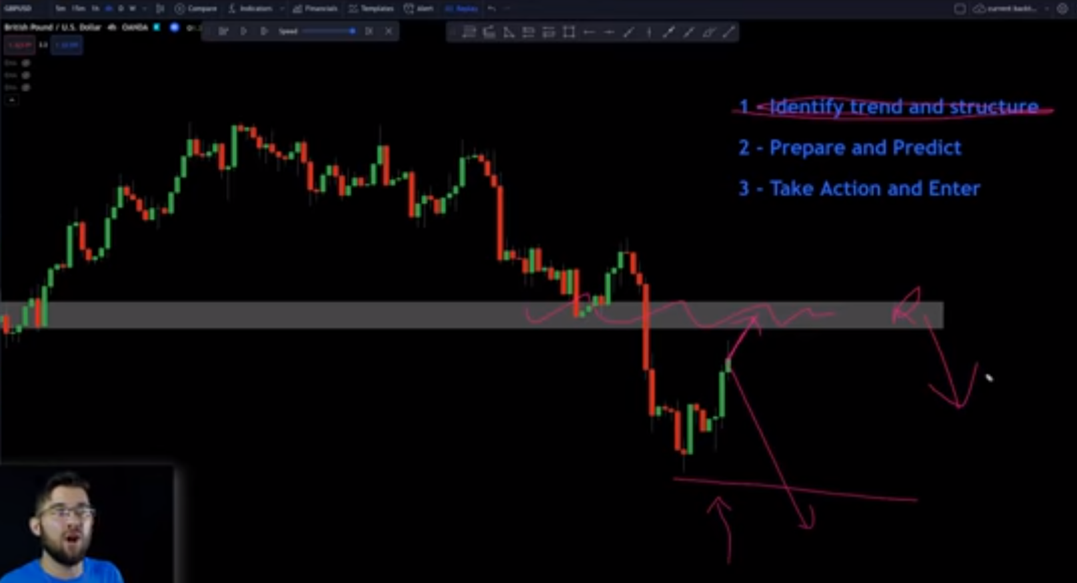

      - Take action and enter.
Drop down to the 1 hour chart for trading opportunities. Look for patterns like the double top or head and shoulders pattern.

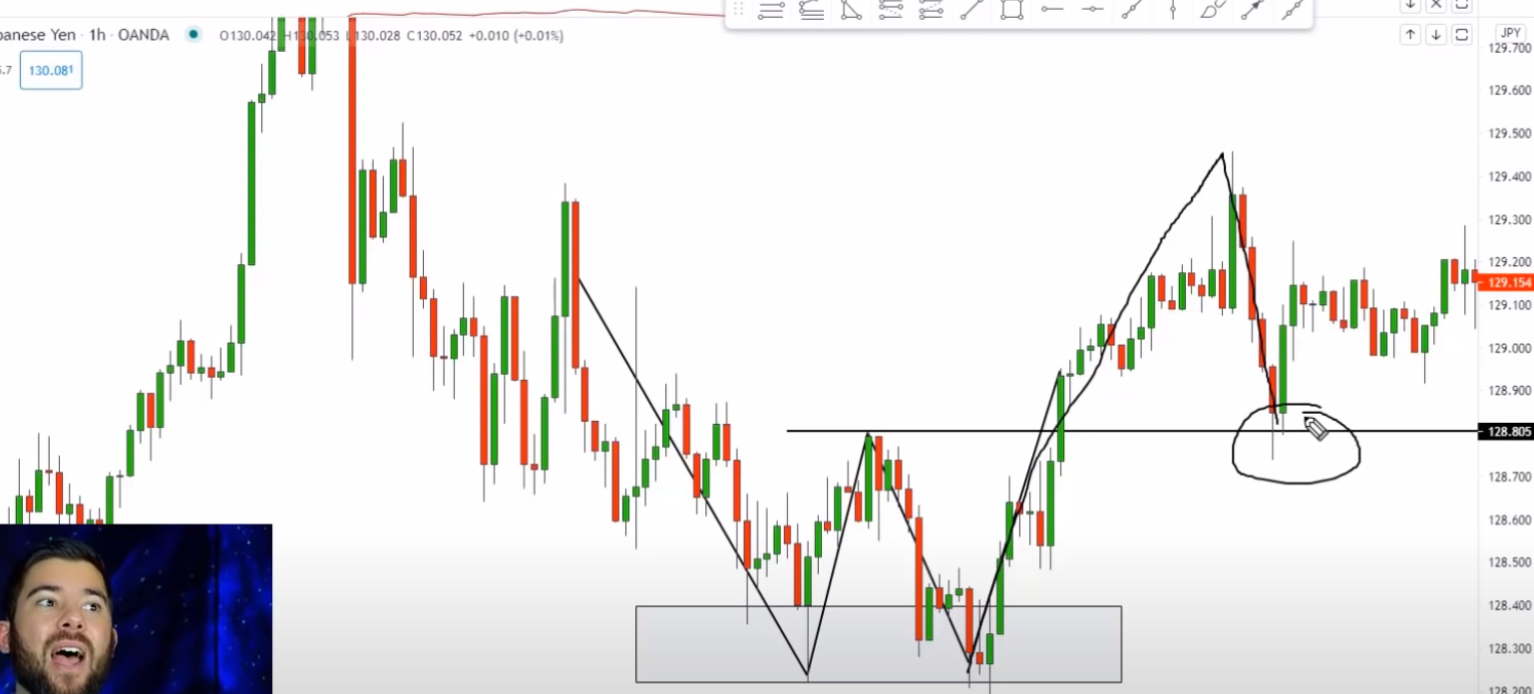

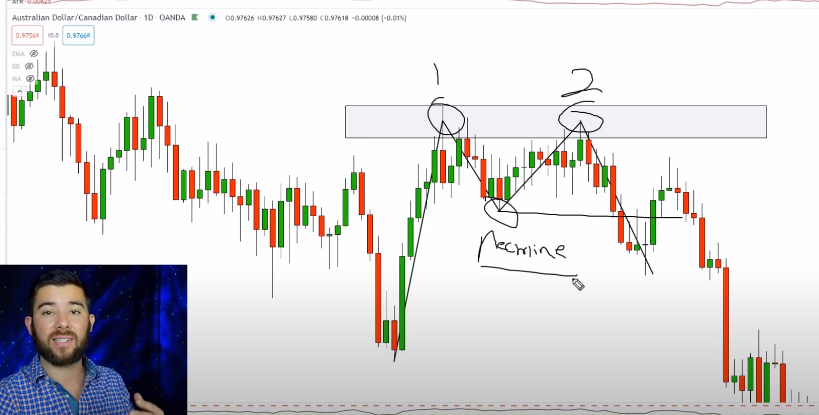

Price action patterns tend to be a bit larger and have between 10 to maybe 50 candles.

- Double tops and bottoms are some examples of price action patterns.

Conditions:
- Wait for the market to break and close above that neckline and then pull back into that neckline.

